Experiment 8: Installing Cassandra on Ubuntu WSL
Objective
To install and configure Apache Cassandra on Ubuntu WSL using Docker, create a keyspace and tables, insert sample data, and execute CQL queries for efficient data retrieval.

Procedure
- Install Ubuntu WSL and update the system.
- Install Docker on Ubuntu WSL.
- Create a project directory.
- Create a docker-compose.yml file for Cassandra.
- Start the Cassandra Docker container.
- Verify that Cassandra is running.
- Connect to Cassandra using cqlsh.
- Create a keyspace named sparkify.
- Create tables for storing music streaming data.
- Insert sample records into the tables.
- Execute CQL queries to retrieve the required data.
- Verify the results and exit Cassandra.

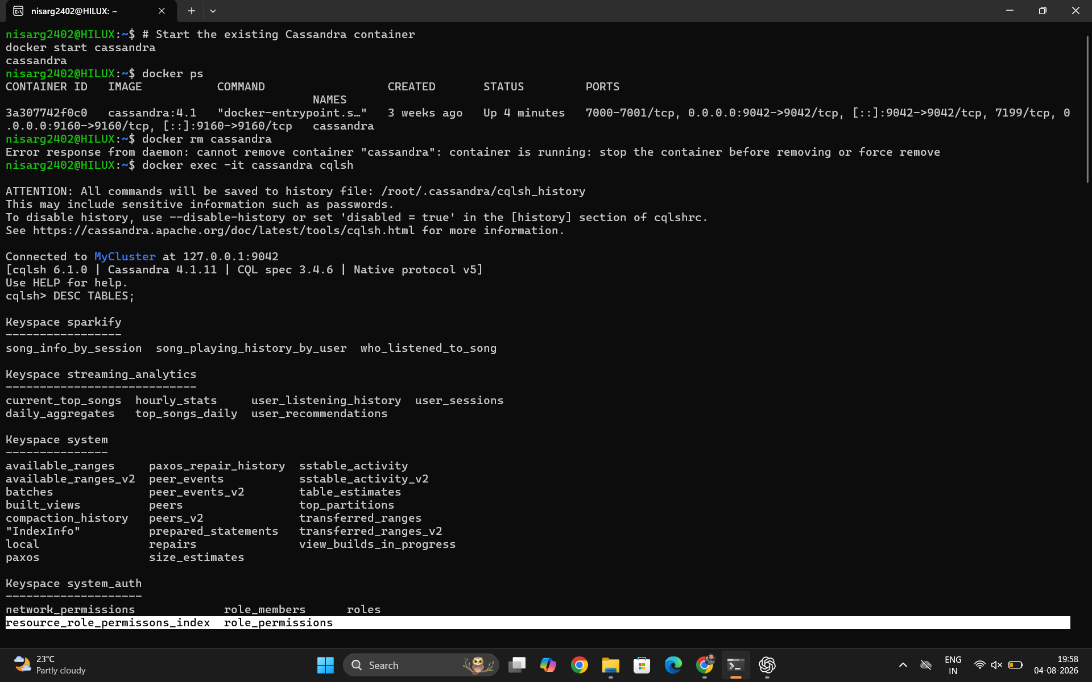
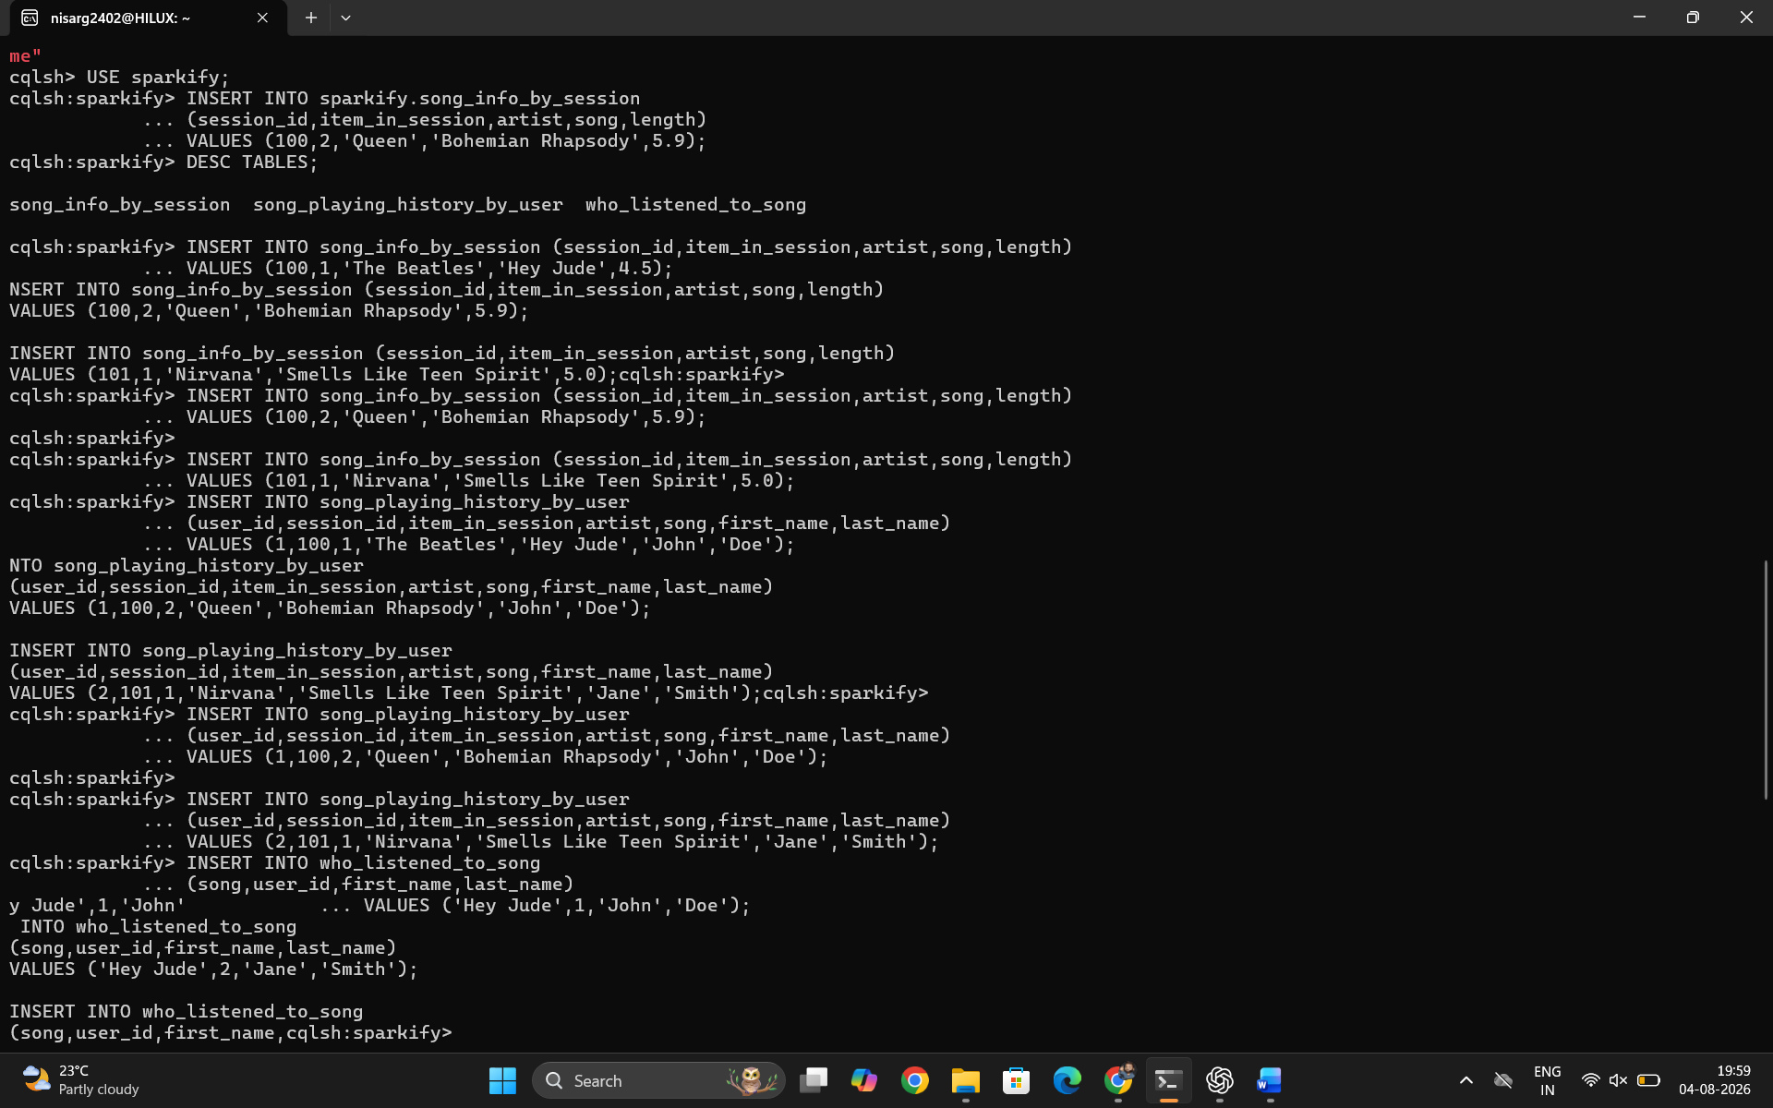
Experiment 9: Cassandra Exercise – Sparkify Music Streaming
Objective
To design a query-based data model in Apache Cassandra for the Sparkify music streaming application, create optimized tables for different queries, insert sample data, and retrieve data efficiently using CQL.

Procedure
- Start the Cassandra Docker container.
- Connect to Cassandra using cqlsh.
- Create the sparkify keyspace.
- Create three tables optimized for different queries.
- Insert sample music streaming data.
- Execute CQL queries to retrieve the required information.
- Verify the query results.
- Exit the Cassandra shell.

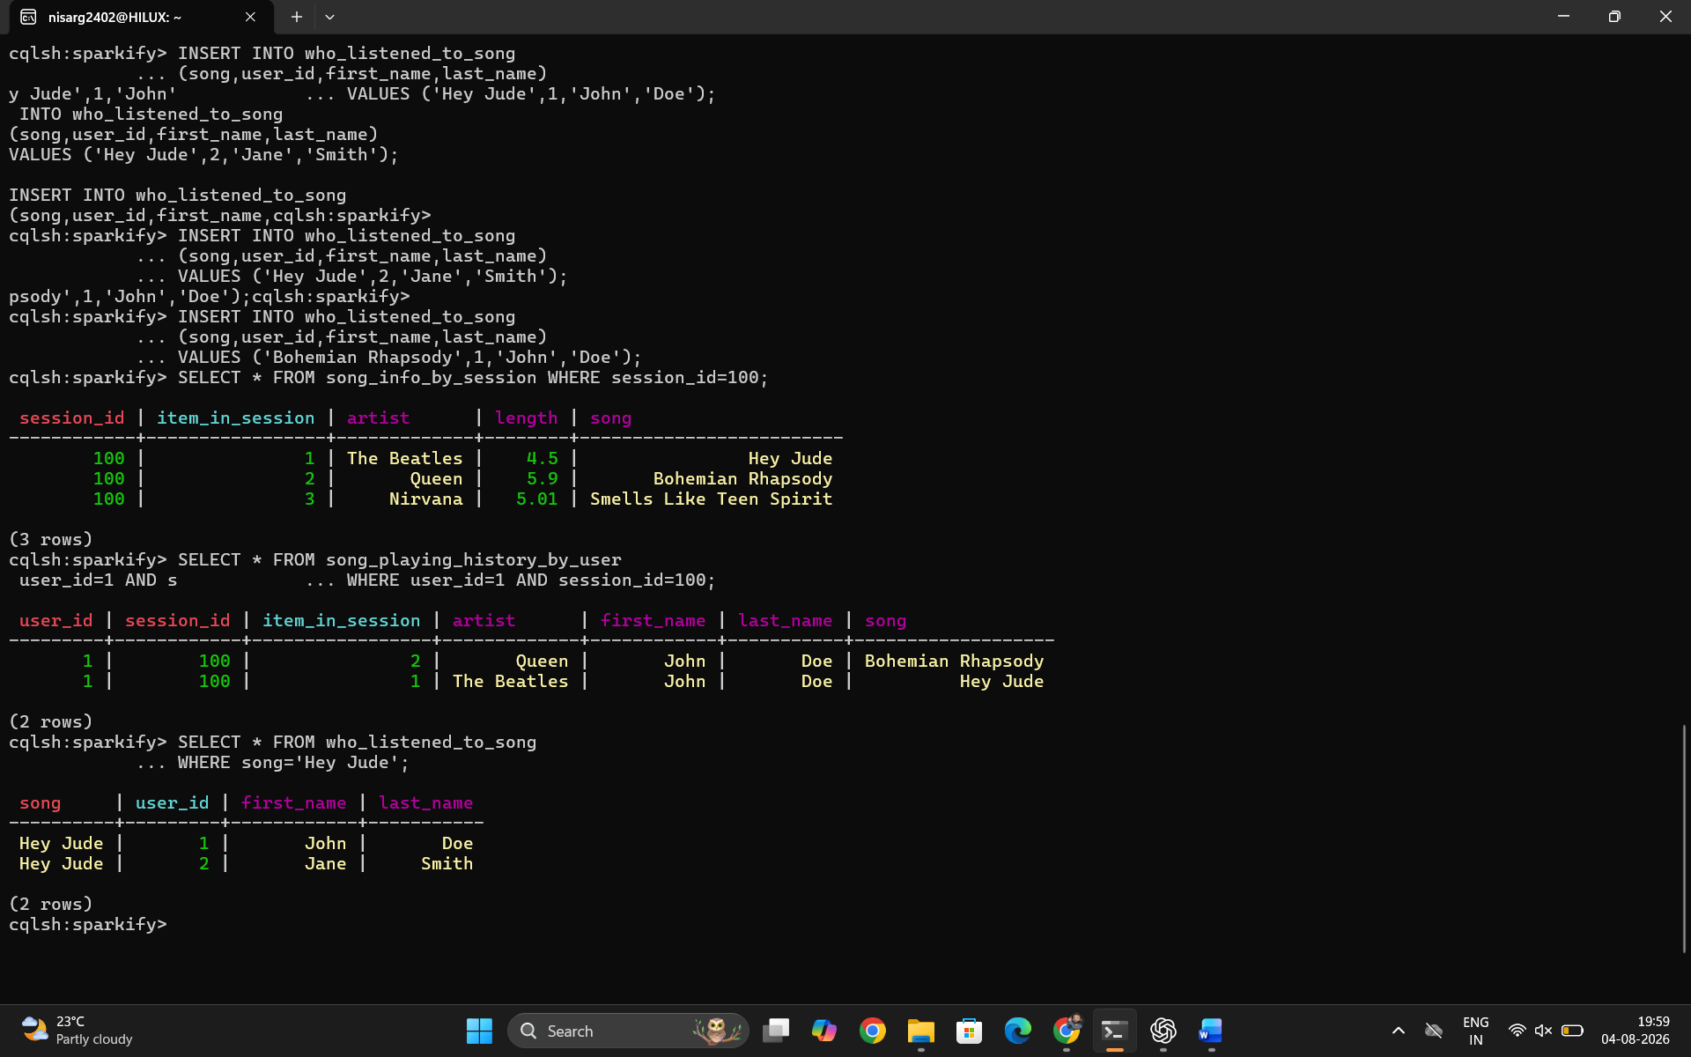
Viva Questions:
1. Data Modeling: Why do we have 3 separate tables instead of 1 table with JOINs?
Answer:
Cassandra does not support JOIN operations like relational databases. Tables are designed based on specific queries. Each table is optimized for a particular query, providing faster data retrieval.

2. Partition Keys: What would happen if we used user_id alone as the partition key for Query 2?
Answer:
Using only user_id as the partition key would store all sessions of a user in the same partition. This would:
- Create very large partitions.
- Reduce query performance.
- Make it difficult to efficiently retrieve data for a specific session.
Using (user_id, session_id) distributes data better and makes queries faster.

3. Clustering Order: Why use ASC for one table and DESC for another?
Answer:
- ASC (Ascending): Displays songs in the order they were played (first to last).
- DESC (Descending): Displays the most recently played songs first, which is useful for viewing recent user activity.
The clustering order is chosen based on the application's query requirements.

4. UPSERT Behavior: What happens when you INSERT a row with an existing PRIMARY KEY?
Answer:
Cassandra performs an UPSERT (Update + Insert).
- If the primary key does not exist, a new row is inserted.
- If the primary key already exists, the existing row is updated with the new values.
- No duplicate rows are created.
Example:
INSERT INTO song_info_by_session
(session_id, item_in_session, artist, song, length)
VALUES (100,1,'The Beatles','Let It Be',4.03);
This replaces the previous song at (session_id=100, item_in_session=1).

5. Consistency: What is the difference between CONSISTENCY ONE and CONSISTENCY ALL?
CONSISTENCY ONE | CONSISTENCY ALL
Requires only one replica to respond. | Requires all replicas to respond.
Faster read/write operations. | Slower operations.
High availability. | Lower availability if any replica is down.
Data may not always be the latest version. | Ensures the most up-to-date data.
Summary:
- CONSISTENCY ONE: Fast, high availability, eventually consistent.
- CONSISTENCY ALL: Slow, strict consistency, all replicas must agree.

